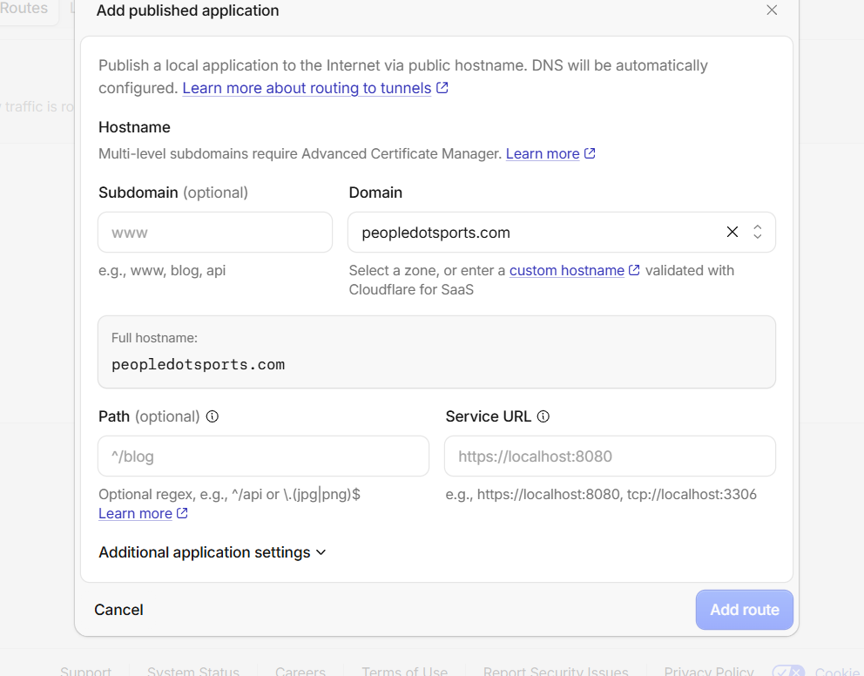
Fill in exactly:
Subdomain: api
Domain: peopledotsports.com
Path: leave blank
Service URL: http://127.0.0.1:8787
The full hostname should change to:
api.peopledotsports.com
Then click Add route.
Before public testing, ensure your local API process is running on port 8787.
Web previewWebsiteOpen
Open in
12:17 PM
it says a dns record has been creaed...
12:19 PM
Worked for 37s
Good—the Cloudflare route is created, and I updated [wrangler.toml](E:/feedom/wrangler.toml) with:
SQL_API_ORIGIN = "https://api.peopledotsports.com"
I tested the public address immediately, but DNS is not visible yet:
No such host is known: api.peopledotsports.com
That is normal just after creating a tunnel hostname. Wait about 2–5 minutes, then open:
https://api.peopledotsports.com/health
Expected result: JSON showing API health and a connected SQL Server database.
Edited wrangler.toml+1-8Review changes
UndoReview
12:19 PM
do we need to update any files in feedom/data-api/|
files?
12:20 PM
Worked for 8s
Yes—only configuration, not SQL tables.
Update E:\feedom\data-api\.env with these values:
APP_ORIGIN=http://127.0.0.1:3000
EDGE_WORKER_ORIGIN=https://feedom.feedom-8f1.workers.dev
INTERNAL_EDGE_SECRET=generate-one-long-random-secret
Then add the same INTERNAL_EDGE_SECRET to the Cloudflare Worker as a secret:
npx wrangler secret put INTERNAL_EDGE_SECRET
Also set the Resend secret there if email is needed:
npx wrangler secret put RESEND_API_KEY
Important: the current Worker cron expects an internal SQL API refresh endpoint at:
POST /api/internal/refresh
That endpoint does not exist in the SQL API yet, so do not deploy/use the cron refresh feature until I add that SQL-side endpoint. The public tunnel itself does not need any further data-api code change; it should work once DNS propagates.
Web previewWebsiteOpen
Open in
12:20 PM
you update the env file and let me know.. i will do the wranger thing in powershell
12:21 PM
Worked for 4m 36s
Updated E:\feedom\data-api\.env with:
APP_ORIGIN=http://127.0.0.1:3000
EDGE_WORKER_ORIGIN=https://feedom.feedom-8f1.workers.dev
INTERNAL_EDGE_SECRET=<generated shared secret>
I left your SQL Server, JWT, Google, and existing email settings untouched.
Now set the Worker secret in Administrator PowerShell:
cd E:\feedom
npx wrangler secret put INTERNAL_EDGE_SECRET
When Wrangler prompts for the value, copy the value after INTERNAL_EDGE_SECRET= from E:\feedom\data-api\.env. Do not paste it into chat.
Then restart the SQL API later so it reads the updated .env file.
Web previewWebsiteOpen
Open in
Edited .env+5-0Review changes
UndoReview
12:26 PM
what secret value i must enter
12:27 PM
Worked for 7s
Use the generated value already in your local .env file—do not type a new one.
In Administrator PowerShell, run this exactly. It reads the secret locally and sends it to Wrangler without displaying it:
$edgeSecret = (Get-Content 'E:\feedom\data-api\.env' | Where-Object { $_ -match '^INTERNAL_EDGE_SECRET=' } | Select-Object -Last 1).Split('=', 2)[1]

$edgeSecret | npx wrangler secret put INTERNAL_EDGE_SECRET
You should see a confirmation that the Worker secret was uploaded.
12:27 PM
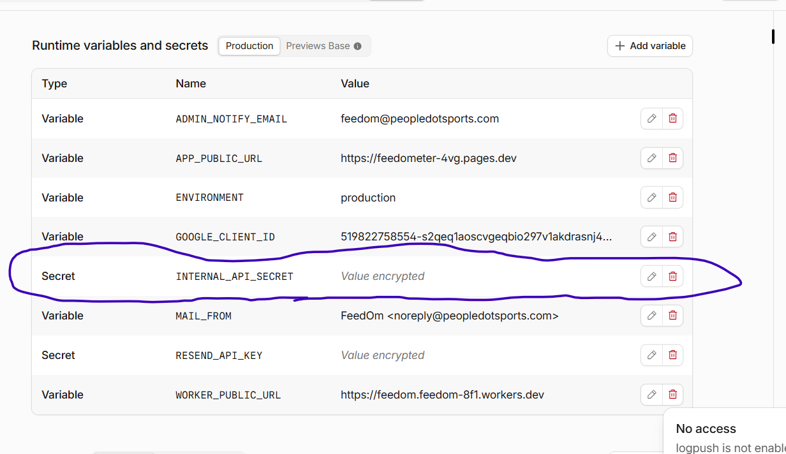
the one i have circled?
12:28 PM
No—that circled INTERNAL_API_SECRET is an existing, separate secret.
Create a new secret named exactly:
INTERNAL_EDGE_SECRET
Use Add variable → choose Secret, then either:
- use the PowerShell command I gave, which uploads the correct matching value automatically; or
- copy the value from E:\feedom\data-api\.env after INTERNAL_EDGE_SECRET= and paste it into the new secret field.
Do not replace or delete INTERNAL_API_SECRET.
12:28 PM

